Retail Meat Store at NAIT
Support NAIT students in the Professional Meat Cutting and Merchandising program. Student prepared beef, pork, poultry, fish, sausages, Soups, and our specialty Charcuterie products.

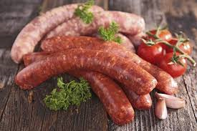

hours of operation
Tuesday, Wednesday, Thursday from 10 am to 5 pm

Parking available behind store location

