ACADEMIC STAFF

ORIENTATION PACKAGE

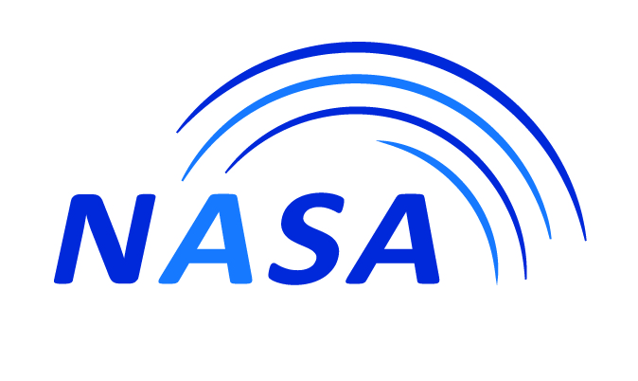

2022-2023
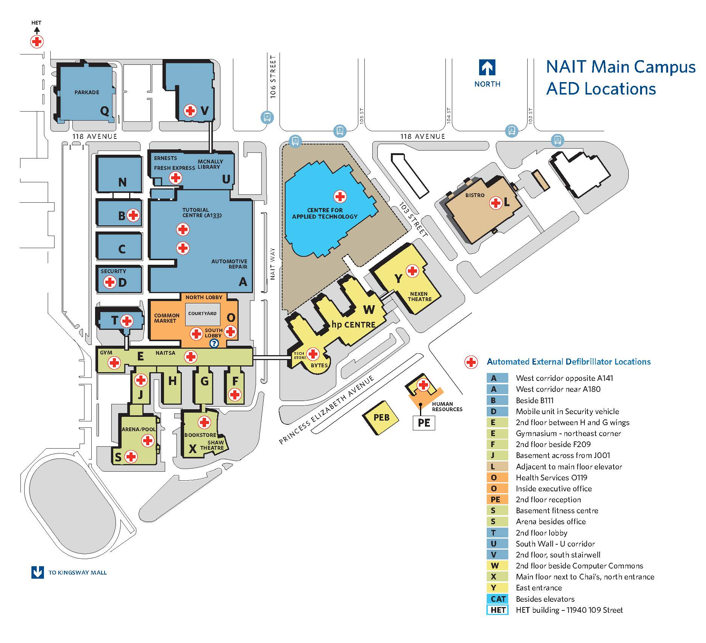
NAIT AED Locations

*This map is currently being updated*

Table of Contents

A. What is NASA and Where Are We? 2
B. NASA Elected Officers, Staff and Committee Members 3
C. Constitutional Bylaw 6
D. Association Structure 6
1. Executive 7
- The Role of Advocacy
- Grievance Process
2. Bargaining Committee 8
- Bargaining Team
- Ratification of a Collective Agreement
3. Finance Committee 8
4. Communications Committee 9
5. Membership Services Committee 9
- Member Services
- Professional Development
6. NAIT Committees – NASA Representation 11
- Board of Governors
- Academic Council
E. Affiliates
1. ACIFA (Alberta College & Institutes Faculties Association) 12
2. CAUT (Canadian Association of University Teaches) 13

APPENDIX: A Collective Agreement
B NASA Elected Officers and Committee Members
C Constitutional Bylaw
D Intercom: Faculty Conversation
E Employee Professional Development Fund

A. WHAT is NASA and WHERE are We?

The NAIT Academic Staff Association (NASA) was established in 1982 as an association under Section 30 of the Technical Institutes Act.
In 2004 the Technical Institutes Act was incorporated into the Post-Secondary Learning Act, which establishes NASA as a corporation and consists of the academic staff members of the technical institute. The NAIT Academic Staff Association has the exclusive authority to negotiate a Collective Agreement on behalf of the academic staff members. The Collective Agreement between the Board of Governors and the Academic Staff Association, which outlines the terms and conditions of employment, is attached as Appendix A.
The Act also indicates that the business and affairs of the Association shall be managed by an Executive, who shall be elected by the staff members.
In 2017, the Post-Secondary Learning Act (PSLA) was amended whereby academic staff/faculty association are classified as a trade union and have the right to strike provision under the Alberta Labour Relations Code (LRC).

Office Location: E230
Email: nasa@nait.ca
Website: www.naitacademicstaff.ca
Telephone: 780.471.8702
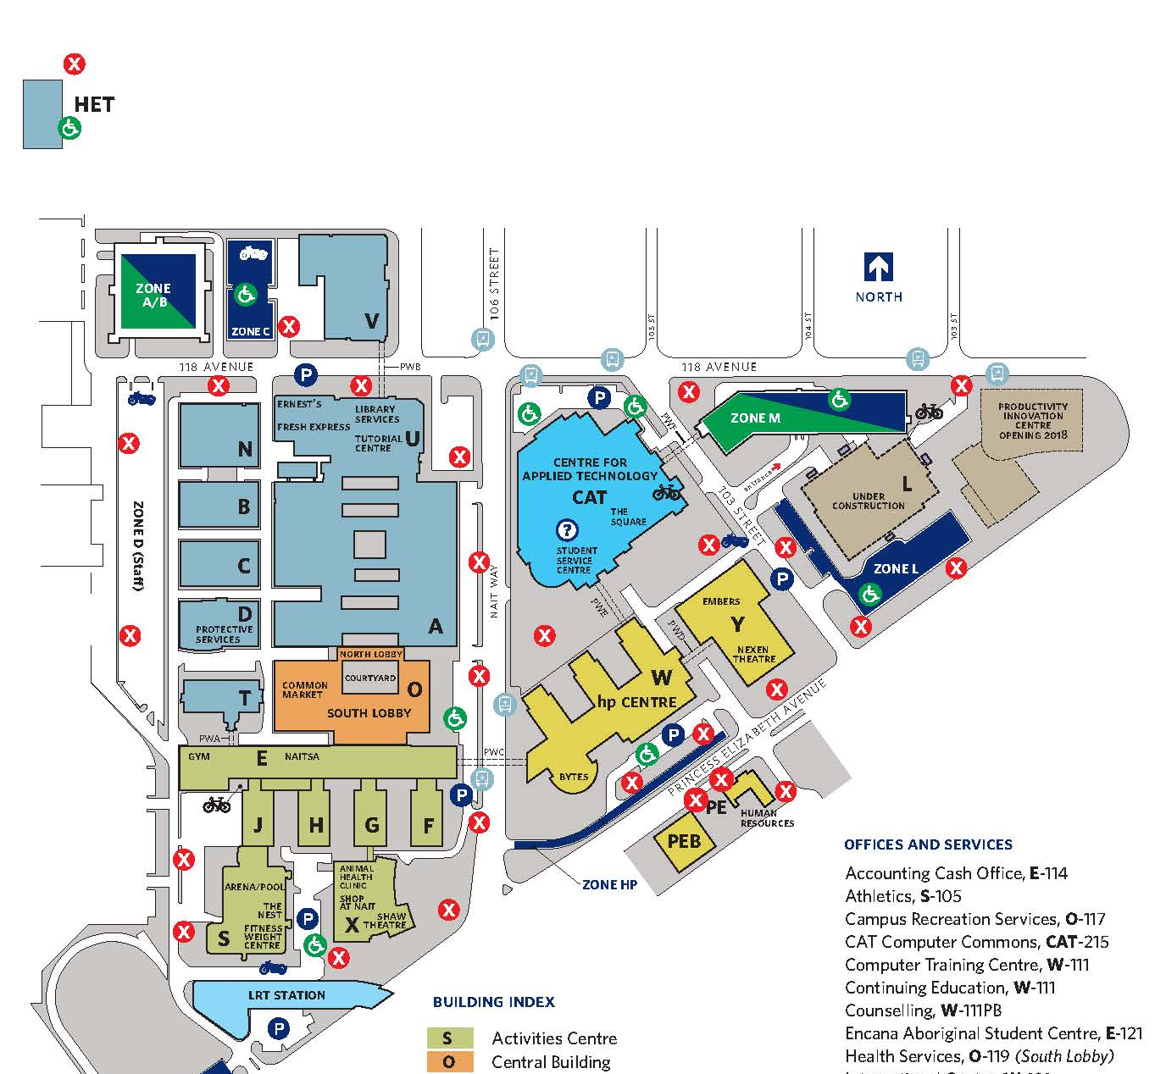

NASA Office

Information about NASA can be found on NASA’s website which is located at http://www.nait.ca/nasa. Information at this site includes:
- NASA/NAIT Collective Agreement
- NASA Constitutional and Policy Bylaws
- Executive and Committee Member Lists
- Corporate Discounts Available to Staff
- Intercom: Faculty Conversation

B. NASA ELECTED OFFICERS, STAFF AND COMMITTEE MEMBERS

The Academic Staff Association is lead by a group of individuals elected pursuant to the Constitutional
Bylaw (see Appendix C). NASA also has three hired staff to facilitate the operations of the organization.

PRESIDENT – SHAUNA MACDONALD

Over the last 18 years, I have taught courses to more than 18 different NAIT programs, giving me insight into the unique needs and challenges within different areas. I have been a sessional instructor who was fortunate enough to become permanent. I have taught daytime, evening, and online courses, and understand the demands of each.

Serving NASA in the following ways has given me a holistic understanding of NASA’s power and function:

- Vice President Membership Services (2020-2021)
- School of Applied Sciences and Technology Representative (2018-2020)
- Board of Governors Representative (2015-2016)
- Academic Council Faculty Representative (2013-2015)

Within each of these roles, I have not been afraid to speak up, ask questions, and represent faculty. I fought against the harmful structuring that put Department Heads in place. I brought forth faculty concerns from different areas of the institute. I represented numerous members at difficult meetings with management. I pursued issues until they received answers. However, I also believe in a balanced approach between actively protecting ourselves while maintaining a collaborative relationship with NAIT.

FINANCE VICE PRESIDENT – JAMES GUTHRIE


James Guthrie joined NAIT in 2001 as an Instructor in the JR Shaw School of Business, where he teaches accounting. Before launching his teaching career at NAIT, he audited and consulted for Deloitte, working with clients like Bell, Microsoft, and the University of Alberta.

James is a Chartered Professional Accountant, Certified Management Accountant (CPA, CMA). He has served the NASA membership for 17 years with eight years as VP Finance and a further nine sitting on the Bargaining and Finance Committees. He has worked to develop a reliable system of internal controls to safeguard NASA’s assets. He promotes a sound fiscal climate and encourages responsible stewardship of Association resources.

MEMBERSHIP SERVICES VICE PRESIDENT – GORDON CUTTING

Gordon Cutting graduated from the University of Alberta in 1997 with a B.Sc. specializing in Mathematics and Physics. After teaching briefly at the U of A he began working at NAIT in 1998 and has been an Instructor at NAIT ever since.

For the last nine (9) years he has been teaching in the Instrumentation Eng.Tech. Program, but before that he has taught for HVAC/BEST and the Physics Department. This experience gives him a unique outlook on teaching here at NAIT and the challenges faced by the varied and diverse programs NAIT delivers, both in the Technologies and Apprenticeships.

As a NASA Executive member for the last 14 years Gordon has seen a great deal of change, both positive and negative, as NAIT strives to meet the challenges set out by government funding fluctuations, Outcome Based Education, the 15 week program adoption and now Restructuring. He believes oversight on the part of the Staff Association is vital during these changes to ensure that staff issues and concerns are addressed and dealt with. Gordon looks forward to the continued opportunity to represent his fellow NASA members in the Association.

COMMUNICATIONS VICE PRESIDENT – CARMEN PUCHYR

Carmen Puchyr graduated with a Diploma in Dental Assisting from NAIT in 1998. She spent ten years working as a Dental Assistant/Receptionist before deciding to change careers and attend NAIT for a second time. She graduated with a Diploma in Diagnostic Medical Sonography in December 2011.
Her 5-year plan to return to NAIT as an instructor in the DMS program turned into an 8-month plan, and she has been with NAIT since August 2012. She has taught theory and labs in ultrasound physics, vascular, abdominal, and obstetrical sonography courses in the past ten years. Instructing at NAIT offers the best of both worlds for Carmen, as she’s equally passionate about sonography and teaching.
In her early years at NAIT, she discovered a new passion, representing NASA members by serving on the NASA Executive. First as a School of Health and Life Sciences representative and now in her new position as the Vice President – Communications. She believes a robust and united association is critical to ensuring the best working conditions for all NASA members.
LABOUR RELATIONS DIRECTOR – Trevor Zimmerman

Trevor has been involved with Alberta's labour movement since 2005: serving as a steward and local executive with Telecommunications Workers Union; steward and chapter executive with Alberta Union of Provincial Employees (AUPE); staff organizer with United Food and Commercial Workers Local 401; and staff roles including organizer, social media, and communications, as well as Essential Services support with AUPE.
His work has included successful campaigns against privatization and pension cuts, as well as support for workers in bargaining who organized collectively to improve their contracts. Those successes were only possible through an engaged and active membership, and Trevor is keen to work with NASA members to defend and improve working conditions at NAIT.

EXECUTIVE OFFICER – ADÈLE WEICHEL

Adèle joined NASA in September of 2015 and prior to that was the Executive Assistant to Keyano College Faculty Association for over 21 years. She provides administrative support to the President, Vice Presidents, Executive, and the many committees of the Association. Among her duties are maintaining the financial records of the Association, tracking task assignments, administering the Employee Professional Development Accounts and ensuring the smooth operation of the NASA Office.
Adèle has a Chartered Professional in Human Resources (CPHR) designation, the Society for Human Resources Management-Senior Certified Professional (SHRM-SCP) designation, a Registered Professional Recruiter (RPR) designation, along with Business Administration, Human Resources Management from Keyano College and Occupational Health and Safety Certificate with Distinction from the University of Alberta.

ADMINISTRATIVE ASSISTANT – LANA BJORKQUIST

Lana, another long-time employee of the Association, was hired in 1992 and works four days per week. She provides reception and administrative support to the Executive Officer, Labour Relations Director, Membership Services, Communications and Bargaining Committees. Lana has a Diploma in Hotel/Restaurant Management and a Certificate in Business Management from NAIT.

In addition to the above individuals, there are many other elected committee members and volunteers who ensure that the mission of the Association is carried out. A list of the current Elected Officers and Committee Members is attached in Appendix B.

C. CONSTITUTIONAL BYLAW

The Post-Secondary Learning Act requires that the Academic Staff Association make bylaws governing its affairs. The Constitutional Bylaw (Appendix C) describes the Association’s mission:
“To serve its membership through contract negotiations and advocacy, while fostering academic identity through open communication, professional and personal development, and mutual respect.”
To fulfill its mission, the Association will:
• Adhere to its bylaws.
• Professionally manage its affairs.
• Enter into negotiations for the purpose of concluding a collective agreement.
• Advocate on behalf of the members.
• Manage its resources.
• Communicate with members.
• Facilitate membership services.
• Foster internal and external interactive communication.

The Constitutional Bylaw also contains articles outlining:
• Membership restrictions and fees.
• Membership meetings.
• Executive responsibilities and composition.
• Appointments, elections and terms of office.
• Financial matters.

• Dissolution and disposition of assets.
• Arbitration.

D. ASSOCIATION STRUCTURE
MEMBERSHIP

Membership Services Committee
Bargaining Committee

Executive

Advocacy
Communications Committee
Finance Committee

1. Executive

The Executive manages the business and affairs of the Association. Legislation relating to the Association is periodically reviewed by the Executive and recommendations to the Constitutional Bylaw are made. The Executive may establish ad-hoc committees and appoint representatives to joint committees of the Association, Administration, and Board of Governors as deemed necessary for the effective operation of the Association. It also provides direction and assistance to NASA committees, communicates issues and activities to the membership, and forecasts and develops short- and long-term plans for the Association.
The voting officers of the Executive are the following:
- President
- Communications Vice President
- Membership Services Vice President
- Finance Vice President
- Twelve School Representatives

The non-voting members of the Executive are the following:
- Two Board Representatives
- Past President
- Labour Relations Director
- Executive Officer

Executive meetings are held every third week (Wednesday) starting in September. Members are welcome to attend all open portions of these meetings. Members may add items to the Executive agenda by calling Adele at 780-471-8504 by noon on the Friday before the meeting.

The Role of Advocacy

The Executive representatives also work on behalf of the membership in an advocacy role. During their meetings they discuss academic staff concerns, solutions and grievances. They also discuss recent settlements, new policies, and/or legislation. In addition, Executive members meet and acquaint new members with NASA; liaise with members and report their issues and concerns to the Labour Relations Director, President, and the Executive; inform members of their rights and responsibilities; and if requested, advocate on behalf of an individual member.
Grievance Process
The Association accepts its responsibility to provide fair representation to members. Article 48 of the Collective Agreement (Appendix A) outlines the Grievance Procedure. An effort should be made to resolve grievances at an early stage through effective consultation while ensuring that time limits outlined in the Collective Agreement are met.
The Association may provide representation at all steps of the Grievance Process as outlined in the Collective Agreement. The Labour Relations Director handles all formal grievances.
Association grievances shall be approved by the Executive prior to filing. The advancement of a member grievance to arbitration also requires the approval of the Executive Arbitration Sub-committee.

2. Bargaining Committee

The Bargaining Committee consists of up to six (6) elected members, one appointed representative from the Executive, the Labour Relations Director, and the President.
The Bargaining Committee reviews and recommends to the Executive policies and procedures pertaining to the collective bargaining process. It also acquires and analyses information, identifies issues and solicits input from the membership, and develops bargaining proposals. The Committee also nominates, for approval by Executive, members for the Bargaining Team.

Bargaining Team
The Bargaining Team consists of the three members appointed from the Bargaining Committee, the Labour Relations Director, and any outside agents as approved by the Executive.
The Team, in conjunction with the Bargaining Committee, discuss the opening proposals with the Executive, presents at the bargaining table the proposals of the Association, and attempts to negotiate a Memorandum of Agreement with the Board of Governors. Regular progress reports are provided to the Executive and the membership. In conjunction with the Bargaining Committee, the Team presents for Executive approval, any tentative Memorandums of Agreement. After the Executive approves the tentative Memorandum of Agreement, the Team signs it, and in conjunction with the Bargaining Committee and Executive, presents it to the membership for ratification.
The Memorandum of Agreement must be ratified by the members and the Board before it comes into effect.

Ratification of a Collective Agreement
The process for ratifying a Collective Agreement is as follows:
a) The Bargaining Team shall ask the Executive to call a Special Meeting (as per Article 4.02 of the Constitutional Bylaw) to present the Memorandum of Agreement for ratification.
b) The ratification vote will take place one working day after the presentation of the Memorandum of Agreement or as soon as possible thereafter.
c) If the Memorandum of Agreement is rejected by the membership, the Bargaining Team (in consultation with the Bargaining Committee and the Executive) will determine an appropriate course of action.
d) If a new Memorandum of Agreement is negotiated, the process described above will be repeated.
e) Prior to arbitration, any changes to the Collective Agreement agreed to by the parties shall be presented to the membership for ratification.

3. Finance Committee

The Finance Committee consists of up to three (3) elected members and the Finance Vice President.
The Finance Committee assists the Finance Vice President in the performance of the duties of that office. It reviews and recommends to the Executive finance-related policies and procedures of the Association. The Committee monitors accounts, evaluates and selects financial services, and manages Association resources. The annual budget of the Association is prepared for approval by the Executive and audited financial statements posted for the information of the membership.

4. Communications Committee

The Communications Committee consists of up to six (6) elected members and the Communications Vice President.
The Committee reviews and recommends to the Executive policies and procedures pertaining to NASA’s corporate image, communications, and legislation. It fosters and maintains interactive communication networks, one of which is the Intercom: Faculty Conversation (Appendix D). The Committee also provides assistance to other committees in developing, gathering, and disseminating information.

5. Membership Services Committee

The Membership Services Committee consists of up to eight (8) elected members and the Membership Services Vice President.
The Committee reviews and recommends to the Executive policies and procedures intended to enhance membership services. It identifies professional development needs of the Association and facilitates social interaction by planning and coordinating events for the membership. It negotiates special rates and discounts for members and promotes professionalism among members of the Association.

MEMBER SERVICES

The Academic Staff Association maintains a “Corporate Sponsor Discount List” which provides staff members with a variety of vendor discounts. Check out the NASA website.
During the year, the Association organizes several social events for the membership. They include a Welcome Back Lunch, Winter Frolic, and a Year-End gathering. Upcoming events are announced via the NAIT email and in the NASA newsletter.

PROFESSIONAL DEVELOPMENT

There are several avenues for members to attain professional development. Article 24 of the Collective Agreement outlines the provision for Institute funded staff development.
A brief synopsis of funding support is outlined below. Contact your Supervisor or the NASA Office for more information.

Funding Support for Professional Development (NASA related)
- Long-term Development Leave (> 21 working days) (Article 24 in CA)
- Educational leaves, experience leaves, secondments and exchanges
- Subject to approval by the Institute.
- Return commitment required.

- Learning Assignment (< 21 working days) (Article 24)
- An $800.00 Employee Professional Development Account (EPDA) will be established each year for each staff member to be used for Learning Assignments or Educational Material. (Refer to Appendix E)

- NAIT Courses
- Tuition waived on “space available” basis, with out-of-pocket expenses of $25+ and textbooks which are negotiable with program (general interest or cost recovery courses are negotiable) (Article 35)
- Support of supervisor
- Basic costs at employee expense
- Becoming a Master Instructor course (BMI) is available at no cost

- NASA Funding
- Supplemental PD funding for the annual ACIFA conference
- Scholarships ($20,000) for family member awards

NASA Educational Award Program
NASA established the NASA Educational Award Program to encourage and assist family members of NASA staff their life-long learning.
Monies toward the NASA Educational Award Program come from interest revenue earned on NASA investments. In 2022-2023 a total of $20,000 will be made available.
- • $20,000 allocated to NASA Member Family Awards.

NASA Member Family Awards
- Who is Eligible?
- Relatives of current NASA members who have completed two years of service at NAIT, shall be eligible to apply for awards. For the purpose of this bylaw “relative” shall mean spouse (including common-law partner and same-sex partner), parent, child or grandchild.
- Relatives, as defined in 3.3 a, of NASA Members who have completed two years of service at NAIT but have retired or become deceased within the preceding five (5) years shall be eligible to apply for awards.
- Applicants must be registered in a full-time post-secondary educational program.
- Applicants may only receive this award once in a lifetime.

More information and application forms are available on the NASA website or at the NASA Office.

6. NAIT Committees – NASA Representation

Board of Governors
The Post-Secondary Learning Act (Articles 40 through 45) establishes the Board of Governors. Two NASA representatives are elected by the membership and appointed by the Minister of Learning.
The NASA Board members attend Board meetings and provide reports to the NASA Executive and the membership. They also communicate issues of the Association to the Board.

Academic Council
The Post-Secondary Learning Act (Articles 46 and 47) outlines the composition, powers and duties of the Academic Council. Academic Council makes recommendation(s) or reports on any matter referred to them by the Board, including policies related to selection and admission of students, courses and programs of instruction, and academic awards.
NASA has six elected members plus the elected President on Academic Council.

Joint Occupational Health & Safety Committee

The Joint Occupational Health and Safety Committee (JOH&SC) plays an important advisory role in our occupational health and safety program. Members are appointed annually, participate in discussions and are consulted on decisions affecting health and safety.
NASA has three members on the JOH&SC.

E. AFFILIATES

1. ACIFA (Alberta Colleges & Institutes Faculties Association)
Telephone: 780-423-4440
Website: http://www.acifaweb.ca

ACIFA (Alberta Colleges & Institutes Faculties Association) is a representative professional association that acts as the provincial voice for its members – the academic staff associations of Alberta’s colleges and technical institutes. Through the collective action and resources of its members, ACIFA promotes the professional and economic well being of college and technical institute faculty in the interest of advancing the quality of post-secondary education in Alberta.
ACIFA represents its members’ interests to government. ACIFA communicates regularly with the Minister and Department of Learning and is recognized as the representative voice for all public college and technical institute faculty.
ACIFA seeks to improve the welfare of its members through lobbying efforts, participating in provincial education coalitions, and providing information and assistance in the collective bargaining process to member associations.
ACIFA sponsors workshops for negotiations of collective agreements and the professional development officers of member associations. Each year, ACIFA and member associations sponsor a spring conference in conjunction with ACIFA’s annual general meeting.
Organization
Several bodies are elected from the ACIFA membership. An elected executive committee of five officers (the President, Vice President Negotiations, Vice President Professional Affairs, Secretary, and Treasurer) runs ACIFA’s day-to-day affairs. A Presidents’ Council – composed of the president of each association plus the executive committee – is the governing body of the association between annual general meetings and gives direction to the activities of ACIFA’s various committees. Working committees include the Negotiations Advisory Committee and the Professional Affairs Committee.
History
ACIFA was formed as a federation of faculty associations including the technical institutes in 1984. ACIFA has a history of service dating back to 1967, first as the Alberta Association of Junior College Faculties and then as the Alberta Association of College Faculties.
Membership
Every member of constituent faculty associations is a full member of ACIFA, entitled to stand for office, serve on committees, and attend general meetings. Institutional and individual associate memberships are also available.
Dues
Association dues are set by special resolution at the annual general meeting and are remitted through the individual faculty associations.

2. CAUT (Canadian Association of University Teachers)

ACIFA holds associate member status with CAUT. Founded in 1951, CAUT is the national voice for academic staff. Today, representing 65,000 teachers, librarians, researchers and other academic professionals and general staff, CAUT is an outspoken defender of academic freedom and works actively in the public interest to improve the quality and accessibility of post-secondary education in Canada. CAUT has always counted notable figures among its members. Former CAUT presidents and activists include past Supreme Court Chief Justice Bora Laskin, MPs Pauline Jewett and Howard McCurdy, and Manitoba Premier Howard Pawley.
CAUT Working for you
From lobbying governments to providing collective bargaining and legal support, CAUT actively advances the social and economic interests of its members. CAUT offers courses, workshops and conferences, and investigates threats to academic freedom. The national office undertakes extensive research, and publishes reports, newsletters, books and a monthly newspaper. CAUT liaises with Canada's media and works in national and international coalitions dedicated to the welfare of academic staff and students.
Where we stand
CAUT actively promotes public post-secondary education that meets the needs of students and the public. We press for public funding and policies to ensure our institutions are accessible and to safeguard the freedom of our members to teach and conduct research unrestricted by commercial or other special interests.
Making a difference
CAUT advances equity and human rights within our profession. We fight for fair working conditions, compensation and benefits that foster quality teaching and innovative research. CAUT works for collegial institutional governance that is publicly accountable and gives the academic community its proper voice.

APPENDIX A

COLLECTIVE AGREEMENT
To view the current Collective Agreement, please visit the NASA website.

APPENDIX B

NASA ELECTED OFFICERS AND COMMITTEE MEMBERS

For Current list of Elected and appointed committee members, please visit the NASA website.

APPENDIX C

CONSTITUTIONAL BYLAW
To view the current Constitutional Bylaw, please visit the NASA website.

APPENDIX D

INTERCOM: Faculty Conversation



For Current and Archived
issues of INTERCOM,
please visit the NASA website.

APPENDIX E

EPDA

Employee Professional Development Account

Employee Professional Development Account (EPDA)

NAIT will contribute $800.00 per year (prorated for part-time staff) to a maximum of $3200 into an individual Employee Professional Development Account (EPDA) for each staff member. (Article 24 of the NAIT/NASA Collective Agreement)

The EPDA is administered and funded by NAIT; therefore, expenses must be in accordance with NAIT guidelines.

Funding can be used to participate in courses, programs, conferences, seminars and workshops, Educational Material (the purchase of subscriptions to professional journals, educational software, reference material or textbooks related to the staff member’s knowledge, skills, and competencies, or tools that directly support professional development) or the payment of Membership Dues/Fees in a Professional Association that is not covered under Article 34.

To find out your
EPDA balance, contact adelew@nait.ca

